Recogito Instructions

Performing Annotations

- Create an account (free) at https://recogito.pelagios.org/
- Unzip test_sets.zip
- Upload each of the text_set_x.txt files to recogito
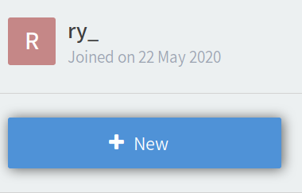 | 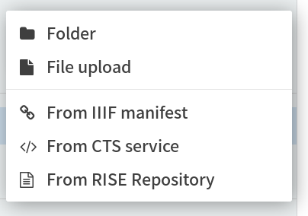
1. Click new | 2. Click “File upload”

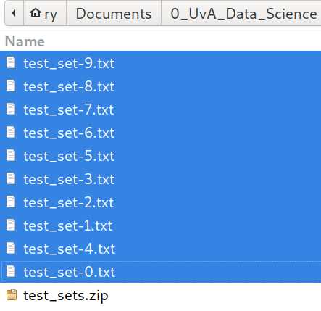 | 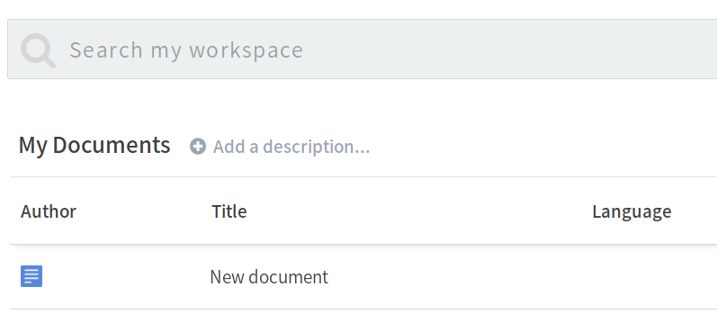
3. select and upload all test sets | 4. The uploaded files can be found as sub-files within the newly created “New document”

- Double click on a “New document” and start annotating.
- Annotate an extract by selecting the text portion and right-clicking
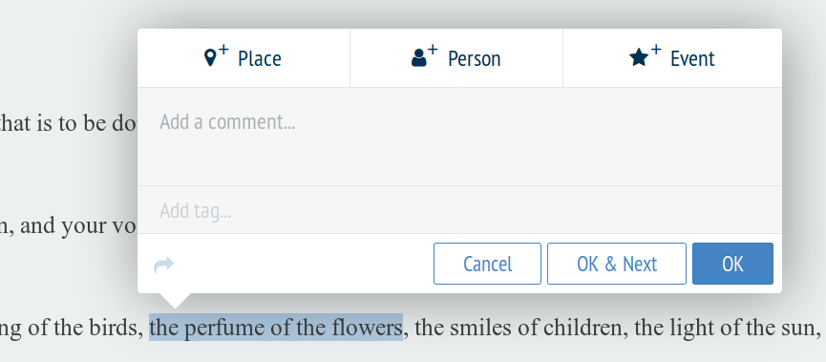
Add tags to the “Add tag...” section at the bottom. Ignore Place, Person, Event buttons.

Refer to Annotation Guidelines for instructions for more detail, available tags are:
tag
d | A smell with a description
o | A smell without a description
v | Smell related verbs
s | Sense of smell alluded to
u | Extracts unrelated to smell  (i.e., non of the above tags apply)

E.g., extract portion tagged as d, a smell with a description.
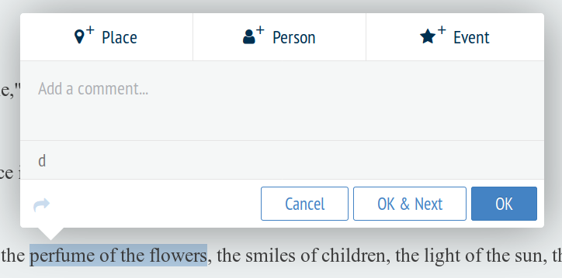

Downloading Annotations
- Once finished, download the annotated document as a TEI/XML. Rename as 0.txt to 9.txt corresponding to text set.
